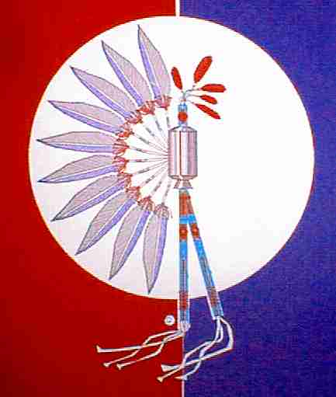
TEXAS GULF COAST TIA-PIAH

BENEFIT POW-WOW

Schedule for 2017-2018
September 16, 2017
November 18, 2017
January 20, 2018
March 17, 2018

St. Pius V Catholic Church Gym
824 S. Main - Pasadena, Tx

Annual April 20 & 21, 2017

A.V. “Bull” Sallas Park
New Caney, TX

Absolutely No Alcohol or Controlled Substances Allowed

COME AND ENJOY OUR POW-WOW!

Visit us at:
www.gulfcoasttiapiah.org
Face Book: JoJo Sweeney

E-mail us at:
tcgtp.jojo@gmail.com

