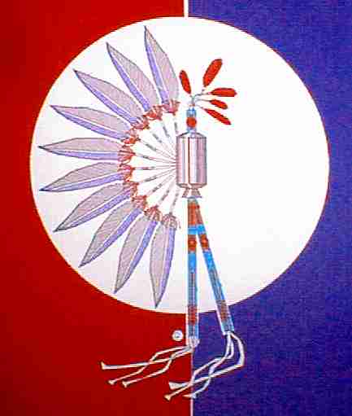**42nd ANNUAL TEXAS GULF COAST TIA**-PIAH POW-WOW

April 12th and 13th, 2019

**Albert V Sallas Park, New Caney Texas**

**21681 McCleskey Rd. New Caney, Texas 77357**

**CONTEST DANCE: Adult Men’s Traditional Straight – Sponsored by The Hesche Family – Prize Money 1st $500.00, 2nd $300.00 & 3rd $200.00**

**Adult Women’s Southern Cloth – Sponsored by The Cornett’s, Sweeney’s & Venzke’s - Prize Money 1st $500.00, 2nd $300.00 & 3rd $200.00**

**Head Singer: Keith Satepeahtaw: Kiowa/Comanche – Lawton, Ok**

**Head Gourd Dancer: Texas Gulf Coast Tia-Piah Headsmen**

**Head Man Dancer: Dave Madden: Osage – Pawhuska, Oklahoma**

**Head Lady Dancer: Haley Madden: Osage – Dewey, Oklahoma**

**Master of Ceremony: TBA**

**Master of Ceremony: Herbert Johnson Jr: Alabama Coushatta - Livingston, Tx**

**Arena Director: Fernando Carballeira: Freer, TX**

**Arena Director: Daniel Cullison: Portland, TX**

**Friday April 12th** 07:00 pm Gourd Dance 08:00 pm Social Dance

**Saturday April 13th** 02:00 pm Gourd Dance 05:00 pm Dinner Break

06:30 pm Brush Dance 08:00 pm Social Dance (Contest Dances)

(Seating is Limited, Bring Your Lawn Chairs)



Take New Caney Exit on Hwy. 59. From intersection of Hwy. 59 and FM 1485 travel on Southbound feeder/frontage road of Hwy. 59 to McCleskey Road. (Look for Albert V. Sallas County Park green sign). Turn right and travel for 1.0 mile to the park entrance. Dance located in covered rodeo arena.

***Absolutely No Alcohol or Controlled Substances Allowed***

**Look us up @ gulfcoasttiapiah.org or Texas Gulf Coast Tia Piah on Facebook**

**Host Hotel Info – Porter Executive Inn & Suites 23998 F.M. 1314 Porter, Texas 77365 (281) 354-9988**

**Additional hotels in local area.**

**For additional information contact: Gary Cornett 281-332-6771 or JoJo Sweeney 903-646-2743 or email us at** **tgctp.jojo@gmail.com**