TEXAS GULF COAST TIA-PIAH

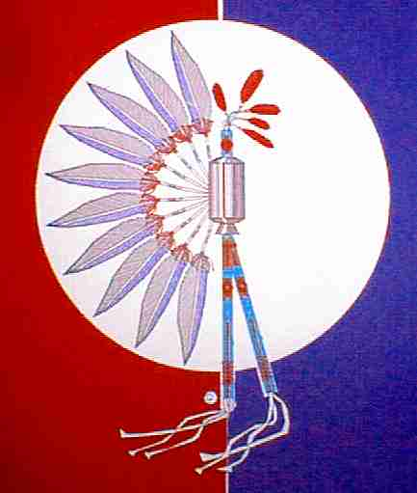
ANNUAL POW-WOW

April 15 & 16, 2016

A V “Bull” Sallas Park
21675-B McCleskey Rd New Caney, TX 77357

Honorees’: Grant & Kay Gaumer
HEAD STAFF
Head Singer Chad Tahcawwickah – Comanche – Cache, OK
Head Gourd Dancers Texas Gulf Coast Tia-Piah Headsman
Head Man Dancer Otto Hamilton - Osage – Pawhuska, OK
Head Lady Dancer Geneva Horse Chief-Hamilton Pawnee/Osage/ Potawatomie/Blackfeet - Pawhuska, OK
Co-Master of Ceremony Gary Kodaseet – Kiowa – Oklahoma City, OK
Co-Master of Ceremony Herbert Johnson, Jr – Alabama Couchatta – Livingston, TX
Co-Arena Director Fernando Carballeira – Freer, T
Co-Arena Director Daniel Cullison – Portland, TX
Program:

Friday

7:00 PM Gourd Dancing
8:30 PM Social Dancing

Saturday

2:00 PM Gourd Dancing
5:00 PM Dinner
6:30 PM Brush Dance
8:30 PM Grand Entry

ABSOLUTELY NO ALCOHOL OR CONTROLLED SUBSTANCES PERMITTED!

Open to the Public!

Visit our website at www.gulfcoasttiapiah.org or call Gary Cornett 281-332-6771

