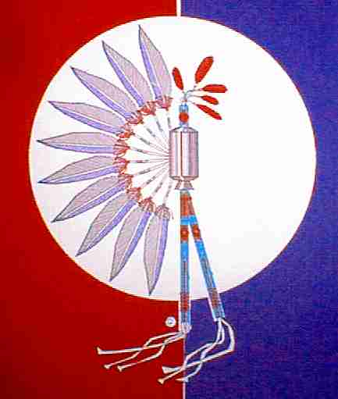 ***TEXAS GULF COAST TIA-PIAH***

# BENEFIT POW-WOW

September 16th, 2017

**COME AND ENJOY OUR POW-WOW!**

St. Pius V Catholic Church Gym, 824 S. Main, Pasadena, TX

Sponsors: Gulf Coast Tia Piah

**Head Singer TBA**

**Head Gourd Dancer TBA**

**Head Man Dancer TBA**

**Head Lady Dancer TBA**

**Master of Ceremony TBA**

**Arena Director TBA**

SCHEDULE

5:00 Members Business Meeting **6:00 Gourd Dancing** 7:30 Intertribal Dancing

**There will be no Pot Luck Dinners this season, Concession Stand only**

Highway 225

W

E

Exit Hwy. 225 at Shaver St. Go South on Shaver for .9 miles. Turn left on Marvick and right into the back parking lot. Please use only the back parking lot.



BRING YOUR OWN LAWN CHAIRS. SEATING IS LIMITED

ABSOLUTELY NO ALCOHOL OR CONTROLLED SUBSTANCES PERMITTED!

**Visit our website at** [**www.gulfcoasttiapiah.org**](http://www.gulfcoasttiapiah.org)

**Follow us on Facebook: Texas Gulf Coast Tia-Piah**

**Attention Members: We are working on a new directory - Please email Jo Jo Sweeney (secretary) with your updated information tgctp.jojo@gmail.com**

Call Gary Cornett 281-332-6771 or Jo Jo Sweeney 903-646-2743