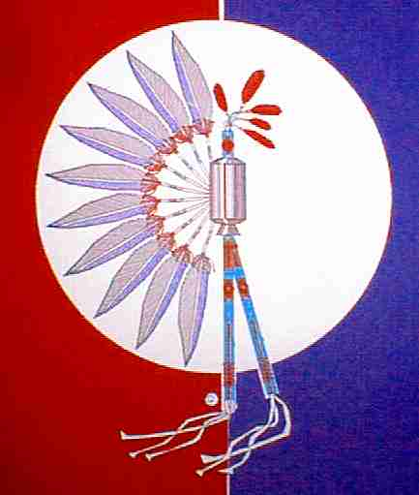**40th ANNUAL TEXAS GULF COAST TIA**-PIAH POW-WOW

April 20 and 21, 2018

**Albert V Sallas Park, New Caney Texas**

**21681 McCleskey Rd. New Caney Texas 77357**

**Honorees: TBA**

**Head Singer: TBA**

**Host Drum: TBA**

**Head Gourd Dancer: Texas Gulf Coast Tia-Piah Headsmen**

**Head Man Dancer: TBA**

**Head Lady Dancer: TBA**

**Master of Ceremony: TBA**

**Master of Ceremony: TBA**

**TBA**

**Arena Director: TBA**

**Arena Director: TBA**

**Friday April 20th** 07:00 pm Gourd Dance 08:30 pm Social Dance

**Saturday April 21st**  02:00 pm Gourd Dance 05:00 pm Dinner Break

06:30 pm Brush Dance 08:00 pm Social Dance

(Seating is Limited, Bring Your Lawn Chairs)



Take New Caney Exit on Hwy. 59. From intersection of Hwy. 59 and FM 1485 travel on Southbound feeder/frontage road of Hwy. 59 to McCleskey Road. (Look for Albert V. Sallas County Park green sign). Turn right and travel for 1.0 mile to the park entrance. Dance located in covered rodeo arena.

***Absolutely No Alcohol or Controlled Substances Allowed***

**Look us up @ gulfcoasttiapiah.org or Texas Gulf Coast Tia Piah on Facebook**

**Host Hotel Info – Porter Executive Inn & Suites 23998 F.M. 1314 Porter, Texas 77365 (281) 354-9988 Additional hotels in local area. For additional information contact: Gary Cornett @ 281-332-6771 or JoJo Sweeney 903-646-2743 or email us at** **tgctp.jojo@gmail.com**